Multiple-choice section

|  |  |  |  |  |  |  |  |  |
| --- | --- | --- | --- | --- | --- | --- | --- | --- |
| Question | 1 | 2 | 3 | 4 | 5 | 6 | 7 | 8 |
| Answer | B | C | A | D | C | D | A | C |

Question 1 [2.3]

B

Let *x* be the third side of the triangle.

From Pythagoras’ theorem:  
*x*2 + 142 = 192*x*2 + 196 = 361  
Subtract 196 from both sides of the equation.  
*x*2 = 165

*x =*

Question 2 [2.1]

C

The hypotenuse is labelled *d*.  
From Pythagoras’ theorem:

*d*2 = *e*2 + *g*2

Subtracting *g*2 from both sides of the equation gives d2 – *g*2 = *e*2.

Question 3 [2.5]

A

Method 1: recognise the multiple of (3, 4, 5)

When the numbers in (3, 4, 5) are multiplied by 5, the new triple is (15, 20, 25); *c* = 25

Method 2: use Pythagoras’ theorem  
*a*2 + *b*2 = 152 + 202 = 625

 = 25; *c* = 25

Question 4 [2.2]

D

Let the hypotenuse be *c*.

*c*2 = 16.282 + 7.432

*c*2 = 320.2433

*c* =  ≈ 17.8953…

*c* = 17.90 (2 d.p.)

Question 5 [2.2]

C

is irrational, so C is incorrect. The other three statements are true.

Question 6 [2.4]

D

The ladder, the wall and the ground form a right-angled triangle.

In the original position, the side lengths are the Pythagorean triple (1.5, 2, 2.5). The original height is 2.5 m.

When the ladder is moved the length of the hypotenuse is 2.5 m and one short side is 1 m. A calculation is needed to find the length of the other short side.

Question 7 [2.2]

A

Let the value of the diagonal be *d*.

*d*2 = 8.822 + 5.182

*d*2 = 104.6248

*d* =

*d* = 10.23 (2 d.p.)

Question 8 [2.5]

C

82 + 152 = 64 + 225 = 289

172 = 289

(8, 15, 17) is the Pythagorean triple.

Multiple-choice total marks: 8

Short answer section

Question 9 3 marks [2.1, 2.2, 2.5]

**(a)** In a right-angled triangle, the hypotenuse is opposite the right angle.

**(b)** To find the length of the hypotenuse, we take the square root of the sum of the squares of the two shorter sides.

**(c)** By showing that the numbers in Pythagorean triples satisfy Pythagoras’ theorem, we show that these numbers could represent the lengths of sides of a right-angled triangle.

**(d)** A square root that is an irrational number is called a surd.

Question 10 3 marks [2.3]

The hypotenuse is 11.  
From Pythagoras’ theorem:  
*k*2 + 82 = 112

**(a)** Maha’s incorrect step: 82 + 112 = *k*2

Nino’s incorrect step: 32 = *k*2

**(b)** Maha thinks that *k* was the hypotenuse.   
His first step should be *k*2 = 112 – 82 or  *k*2 + 82 = 112.

Nino incorrectly subtracts 8 from 11 before squaring the values.

Question 11 2 marks [2.1]

Δ*PQR*

14.052 + 12.252 = 347.465

18.652 = 347.823

14.052 + 12.252 ≠ 18.652

Pythagoras’ theorem does not hold.

Δ*PQR* does not contain a right angle.

Δ*STU*

20.402 + 21.422 = 874.976

29.582 = 874.976

20.402 + 21.422 = 29.582

Pythagoras’ theorem holds.

Δ*STU* has a right angle at *U*.

Question 12 2 marks [2.1]

*t*2 + 11.432 = 12.982 or *t*2 = 12.982 – 11.432*k*2 + *m*2 = *l*2 or *l*2 = *k*2 + *m*2

Question 13 1 mark [2.1]

Lengths should be very close to accurate in student workings.

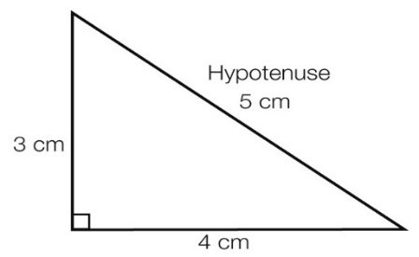

Question 14 2 marks [2.2]

*a*2 = 25.822 + 5.122

*a*2 = 692.8868

*a* = 

*a* = 26.32 (2 d.p.)

Question 15 2 marks [2.2]

*h*2 = 52 + 62

*h*2 = 25 + 36 = 61

*h* = 

Question 16 2 marks [2.3]

Let *x* be the unknown side.

*x*2 + 6.262 = 18.762

*x*2 = 18.762 – 6.262

*x*2 = 312.75

*x* =

*x* = 17.68 (2 d.p.)

Question 17 2 marks [2.3]

*x*2 + *x* 2 = ()22*x*2 = 14  
Divide both sides of the equation by 2.  
*x*2 = 7

*x =*

Question 18 2 marks [2.3]

*m*2 + 5.132 = 7.352

*m*2 = 7.352 – 5.132

*m*2 = 27.7056

*m* =

*m* = 5.26 (2 d.p.)

Question 19 3 marks [2.4]

Let *w* metres be the height of the top of the ladder.

*w*2 + 0.92 = 1.82

*w*2 = 1.82 – 0.92

*w*2 = 2.43

*w* = 

*w* = 1.56 (2 d.p.)

Difference between ladder and picture heights = 1.65 m – 1.56 m = 0.09 m or 9 cm

The top of the ladder is 9 cm below the picture.

Question 20 3 marks [2.4]

The 370 m long rope is the hypotenuse of a right-angled triangle. One of the shorter sides is formed by the 350 cm pole.

Let *x* cm be the distance between the base of the pole and a peg.

*x*2 + 3502 = 3702

*x*2 + 122 500 = 136 900

*x*2 = 14 400

*x* == 120

Each peg is 120 cm from the base of the pole.

The distance between the pegs is 240 cm.

Question 21 2 marks [2.5]

|  |  |
| --- | --- |
| **(a)** Method 1: recognise triple (5, 12, 13)  Method 2: use Pythagoras’ theorem *5*2 + *b*2 = 132  *b*2 = 169 – 25 = 144  *b* =  *b* = 12 | **(b)** Method 1: recognise triple (9, 40, 41)  Method 2: use Pythagoras’ theorem *h*2 = 92 +402 = 1681  *h* = = 41  *h* = 41 |

Question 22 *2 marks* [2.5]

**(a)** 152 + 632 = 4194

652 = 4225

152 + 632 ≠ 652

Pythagoras’ theorem does not hold.

Therefore (15, 63, 65) is not a Pythagorean triple.

**(b)** 202 + 212 = 841

292 = 841

202 + 212 = 292

Pythagoras’ theorem holds.

Therefore (20, 21, 29) is a Pythagorean triple.

Short answer total marks: 31

Extended answer section

Question 23 5 marks [2.1]

**(a)**

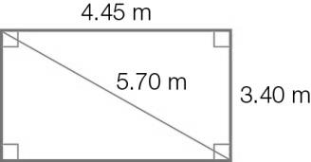

**(b)** 4.452 + 3.402 = 31.3625

5.702 = 32.49

4.452 + 3.402 ≠ 5.702

Pythagoras’ theorem does not hold so the room is not ‘square’.

**(c)** Student answers will vary.

Method 1:

4.452 + 3.402 = 31.3625  
Adjust the diagonal to≈ 5.60 (2 d.p.)

Method 2:  
The measurements are close to a (3, 4, 5) triple.  
Multiplying this triple by a number just over 1 will ensure a ‘square’ room with similar dimensions to the original plan.

For example, multiplying by 1.14 gives (3.42, 4.56, 5.70).

If the length is increased by 9 cm and the width by 2 cm, Pythagoras’ theorem holds and the room is ‘square’.

Question 24 9 marks [2.2, 2.4]

(a)

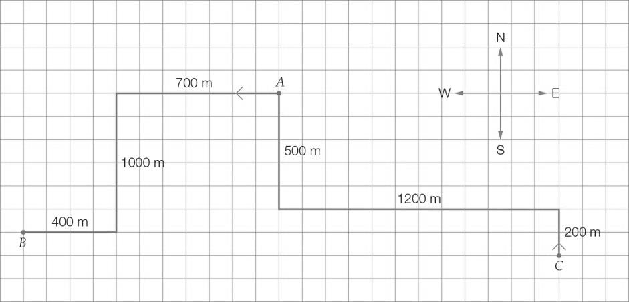

**(b)** Mark:

700 + 1000 + 400 = 2100 m

Nuala:

200 + 1200 + 500 = 1900 m

2100 – 1900 = 200 m

Mark walks 200 m further than Nuala.

**(c)**

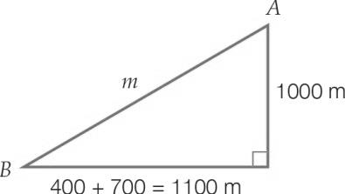

Let the direct distance from the train station to Mark’s house be *m.*

*m*2 = 11002 + 10002

*m*2 = 2 210 000

*m* =

*m* = 1486.61 (2 d.p.)

The distance from point *A* to point *B* is 1486.61 metres.

**(d)**

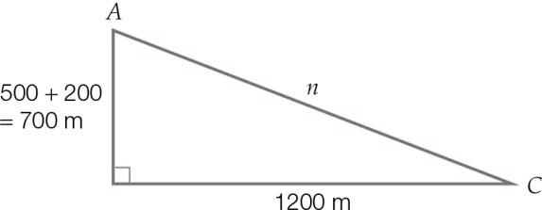

Let the direct distance from Nuala’s house to the train station be *n.*

*n*2 = 12002 + 7002

*n*2 = 1 930 000

*n* = 

*n* = 1389.24 (2 d.p.)

The distance from point *C* to point *A* is 1389.24 metres.

**(e)** 1486.61 – 1389.24 = 97.37 m

Nuala lives closer by 97.37 m.

Question 25 5 marks [2.5]

**(a)** Multiplying each number by 2 gives:

**(i)** (18, 24, 30)

**(ii)** (48, 286, 290)

**(b)** (72 – 1) = 24, (72 + 1) = 25

If (*b*2 – 1) = 112

*b*2 = 2252

*b* = 15

(152 + 1) = 113

|  |  |  |  |
| --- | --- | --- | --- |
| *b* | (*b*2 – 1) | (*b*2 + 1) | Triple |
| 7 | 24 | 25 | (7,24, 25) |
| 15 | 112 | 113 | (15, 112, 113) |

The new triples are (7,24, 25) and (15, 112, 113).

**(c)**

|  |  |  |  |  |  |
| --- | --- | --- | --- | --- | --- |
| *g* | *h* | *g* + *h* | *gh* |  | Triple |
| 2 | 4 | 6 | 8 | = 10 | (6, 8, 10) |
| 5 | 7 | 12 | 35 | = 37 | (12, 35, 37) |

The new triples are (6, 8, 10) and (12, 35, 37).

Extended answer total marks: 19

TOTAL test marks: 58